Week 1 Git Commands

# Tasks

Clone the VC Repo

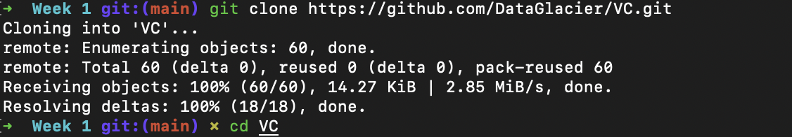

Create a new branch + Checkout Newly created branch

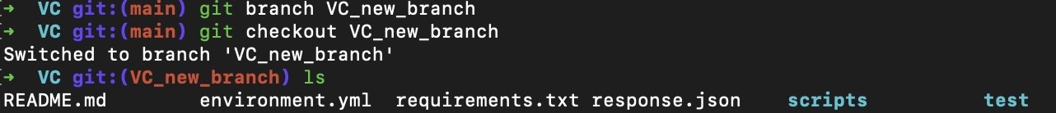

Run the add.py and provide your name and fav sport as input

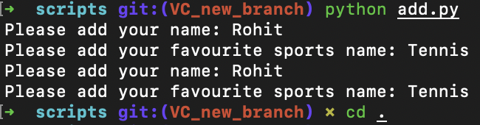

Pytest test/test.py -s

Add/Commit/Push Changes to Repo

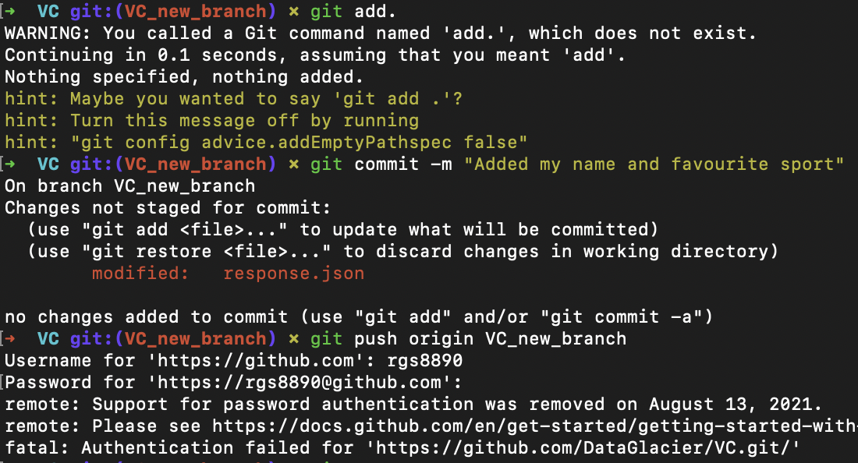

Push Changes to Own Repo

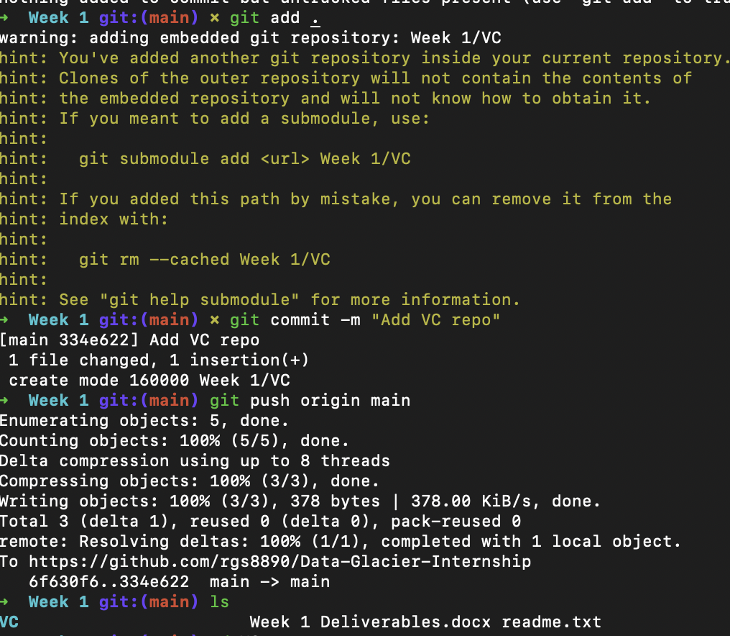

This did not work… so we try to fork the repository instead, then we decide to clone it into our Data Glacier git repository



